RENTAL AGREEMENT

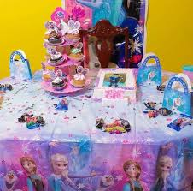
Kingston Rentals

Contact us at:
Email: kingstonrentals@hotmail.com
Contact number: (876) 480-7087

Table of Contents

Contents
Table of Contents 2
Introduction 2
Rental Terms and Conditions 3
Payment and Reservation 4
Rental Policy 5
Damage and Loss Fees 6
Client and Rental Information Form 8
Contact us at: 9

Introduction

Kingston Rentals is a trusted provider when it comes to event rentals. We are dedicated to providing our customers with remarkable services and equipment for all different kinds of occasions, like weddings, parties, work events and more. We supply events with an ample amount of items of items for rental. We have state-of-the-art audiovisual equipment, decorative accents, beautiful light equipment, furniture, and any other party supplies you need in order to provide our clients with an unforgettable experience.

This rental agreement clearly examines the terms and conditions Kingston Rentals supplies both equipment and services under. The purpose of this agreement is to create an understanding between both the client and the company in relation to the roles and what is expected of both the client and the company. These terms and conditions also serve as a way to prevent any disputes that could potentially arise between the client and the company.

Rental Terms and Conditions

Client Responsibilities:
- Clients must treat all rental items with care as any damages done to our equipment will result in an additional fee.

- Clients must return all equipment by the date and time agreed upon.

- Clients must ensure that the location of the event is prepared for the delivery and setup of the equipment upon our arrival.

Company Responsibilities:
- All rental equipment will be delivered on time.

- All equipment delivered will be in good condition, but if any equipment is found to be defective we will offer a free replacement.

- We will assist with the setup of equipment where necessary.

Payment and Reservation

- Payment and Reservation: In order to secure your booking with us a 50% deposit is required, and full payment for equipment must be received at least one week prior to the event.

- Payment Method: We accept payments in cash, online bank transfers, and payment using either a credit or debit card.

- Cancellation: Clients are allowed to cancel up to two weeks before the date of the event and get a full refund, however any cancellation less than two weeks prior to the event will result in the deposit being deducted from the refund.

Kingston Rentals

Rental Policy

- Unchanged: If the equipment is given back in the same state that it was originally rented in, there will be no additional fee required.

- Minimally Damaged: If there is minimal damage done to the rental equipment, there will be an additional charge of 25% of the rental fee.

- Moderately Damaged: If there is moderate damage done to the rental equipment, there will be an additional charge of 60% of the rental fee.

- Severely Damaged: If there is severe damage done to the rental equipment, there will be an additional charge of 125% of the rental fee.

- Not Returned: If rental equipment is not returned to the company after use, there will be an additional charge of 125% of the rental fee.

Damage and Loss Fees

Here is a table describing the different classifications of damage,
along with a visual example of each.
Classification of Damage | Description | Examples
Unchanged | The equipment is given back in the same condition that it was received in. | 
Minimally Damaged | The equipment has light scuff marks or scratches, or the equipment has stains that can be removed by cleaning. The damage done to the equipment is solely done to the exterior and the equipment still works perfectly. | 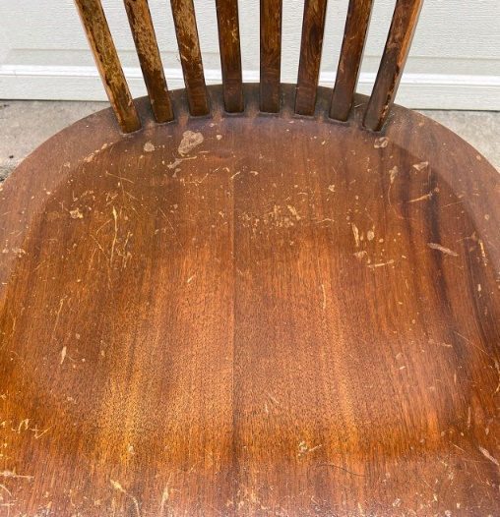
Moderately Damaged | The equipment has visible damage done to it which compromises the structure of the equipment, making it less functional. | 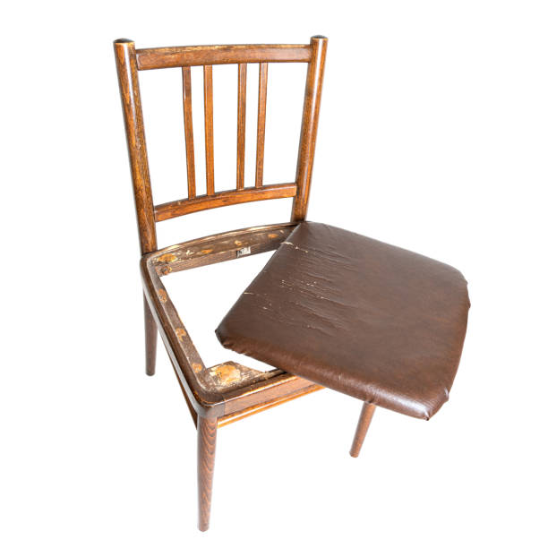
Severely Damaged | The equipment has been damaged beyond repair, and can no longer function. | 

Client and Rental Information Form

Client Details
Full Name | Please enter your full name
Company Name | Please enter your Company Name
Company Address | Please enter your Company Address
ID Type | Please enter your ID Type
ID Number | Please enter your ID Number
Date of Birth | Click here to enter a date.
Equipment Details
Name of Equipment | Please enter your full name
Make/Manufacturer Model | Please enter your full name
Date Required | Click here to enter a date.
Returned Section(To be filled out by the company)
Date Returned | Click here to enter a date.
Condition | Choose an item.
Total Amount Charged | Please enter the total amount charged
Inspected by: | Please enter the full name of the inspector

Contact us at:
Email: Kingstonrentals@hotmail.com
Contact Number: (876) 480-7087

